

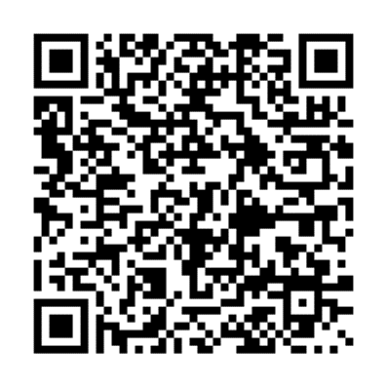

**TN Govt**

**Govt of Tamil Nadu**

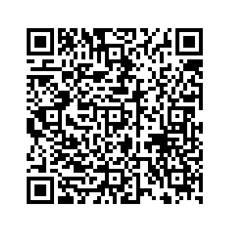

**TNGST**

**Tamil Nadu State Govt Teachers**

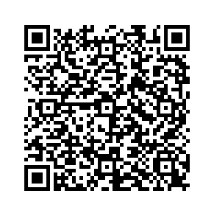

**DMADM**

**Municipality & Municipal Administration**



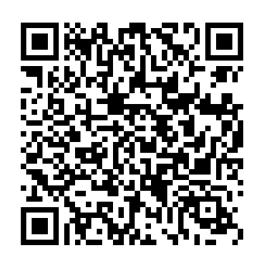

**TNPOLI**

**Tamil Nadu Police**

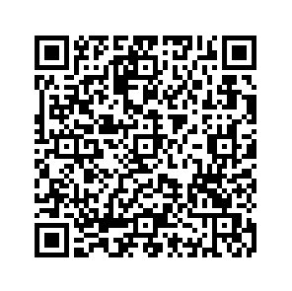

**TNFUS**

**Tamil Nadu Forests Uniformed Services**